Draft survey protocols for the British herpetofauna
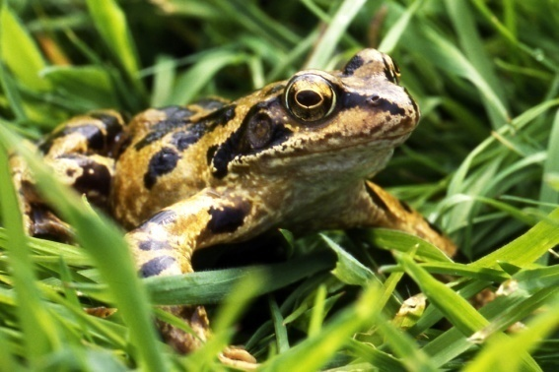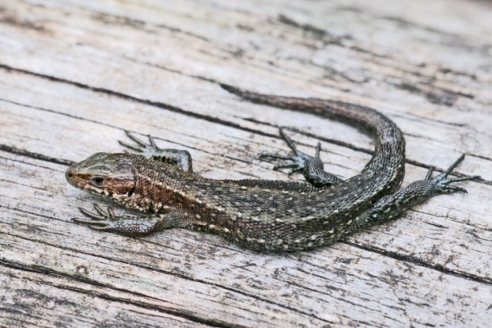
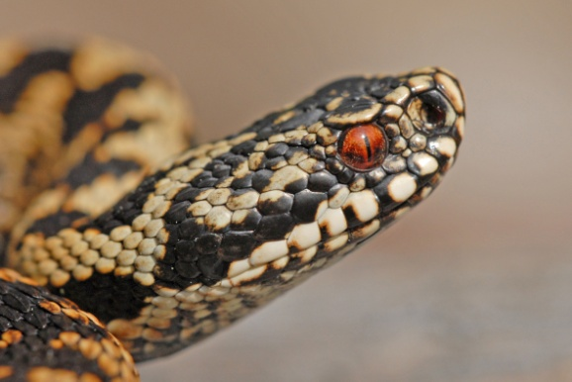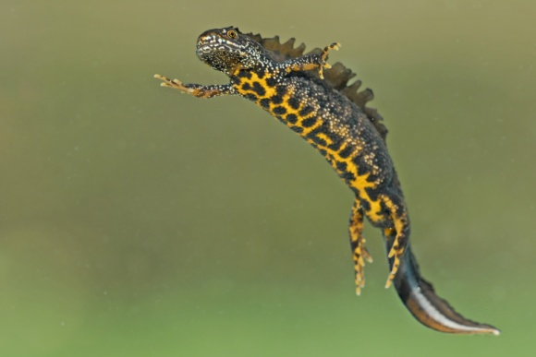

December 2012

IMPORTANT NOTICE
The draft survey protocols contained in this document are for consultation purposes only. They do not represent official policy, and in particular are not intended to necessarily represent the views of Natural England, Scottish National Heritage or the Countryside Council for Wales. Nor are the recommendations contained therein intended to be comprehensive. For example, recommendations are not given on the design of traps, artificial cover objects or on habitat assessment, although the authors recognise all of these to be important issues in the design of a survey programme for the herpetofauna of the UK. For more up to date information please visit our website, www.xxxxxx, where there will also be an opportunity to comment on these proposals during the period 6th – 27th December 2012.

Introduction
Different protocols for surveying amphibians and reptiles have been in existence for some years. However, after a peak of activity around the millennium, e.g. Gent and Gibson (1998), there has been comparatively little new information on the subject in recent years (JNCC 2004 and Gleed-Owen et al. 2005 being the major exceptions), despite increasing interest in the subject from both volunteer and professional surveyors, and recent advances in techniques.
Here we seek to incorporate recent research into existing guidance, having tried to establish needs by means of a series of workshops held around the UK. These were held between spring 2011 and spring 2012 and identified key needs as follows:
• Current methodologies for assessing amphibian populations can be standardized relatively easily, and there is a general consensus about the effectiveness of different methods.
• Current methodologies for reptiles are less easy to standardize and there is less consensus on the effectiveness of different methods.
• Variation in detectability of individuals, populations and species over time and between sites remains a challenge to standardization of survey protocols.
• Views varied on the usefulness of statistical models in improving the design and analysis of surveys, but the majority of participants agreed that they had the potential to provide more robust population assessments.
• Any modelling software incorporated into revised guidance needs to be user friendly. The use of such models may require extensive training, with the constraints of budgets, time and end-user resistance. However, in the longer term, such tools may ultimately allow the design of more cost-effective survey protocols.
• Removal (i.e. catch depletion) modelling was regarded as having considerable potential, especially for those involved in mitigation projects.
• Although habitat assessment was excluded from the workshops, the application of spatial and landscape-level modelling to amphibian and reptile surveys can guide survey effort, provide assessments of habitat suitability, and predictions of occurrence.
• In general, surveys in Scotland operate at larger spatial scales than in England and Wales and protocols need to take account of this.
• There is an issue as to whether indices (simple counts) or densities (such as animals per square metre) are best, as both can be misleading in some circumstances. Although they are difficult to defend statistically, peak counts were still regarded as valuable measures of the minimum number of animals present.
• For larger scale surveys management of data may be a higher priority than data collection and analysis. For example, in a national survey all analysis could be done by a single specialist rather than individual surveyors. However, resulting issues include data ownership and coordination of effort.
• Specific targets and timescales need to be clearly defined in line with the conservation goals. Changes to survey protocols are unlikely to be accepted unless clearly and unambiguously incorporated into national best practice guidelines.
Some of the issues raised in these workshops are resolved here, particularly where supporting evidence is now available. Others require further research. In particular, the issue of catch depletion (population removal from a site), mentioned above, requires greater attention. Fortunately a number of suitable data sets have been made available, and it should be possible to incorporate guidance into later versions of this document. Habitat assessment is again excluded from this document as it lies outside the scope of the project; however, as stated above, habitat assessment offers huge potential for the future. The habitat suitability index (HSI) for great crested newts (Oldham et al. 2000) demonstrates what can be achieved using a habitat assessment approach. Equally, analysing traces of DNA at a site to determine the status of a species has enormous future potential for survey and monitoring (Thomsen et al., 2011)

Type of survey
In this document we make recommendations for completing surveys for both amphibians and reptiles. Although amphibians have different survey requirements to reptiles there are some general principles applying to both groups that stem from the purpose for carrying out the survey. We recognise surveys at four different levels, with increasing amounts of survey effort required:
- Presence/Absence surveys
These are basically simple surveys, carried out for a number of purposes, but with the common intention of determining the likelihood of whether a species, or number of species, are present or absent on a particular site. Typical uses include for distribution of species and risk assessment in advance of development. Statistical analysis of the data obtained can be carried out at a central point remote from the surveyor if required. Programs to complete analysis, such as PRESENCE, are readily available, and allow the estimation of site occupancy and detectability of the species at a landscape level.
- Population counts
Population counts aim to go one stage further than presence/absence surveys, and give an idea of the relative abundance of a species without the need of the much greater commitment required for a population estimate. Population counts typically involve a series of surveys, with the peak count of each species being used. Peak counts are difficult to defend statistically, as they do not take account of variations in detectability from site to site. They can therefore be misleading, but many practitioners prefer them to densities and population estimates for ease of data collection.
- Population densities
Population densities provide slightly more detail than population counts, and divide the counts by some measure of effort (e.g. numbers of amphibians per 2 m of shoreline; number of amphibians per trap; number of reptiles per hour of survey effort). Most of the limitations that apply to counts also apply to densities and they are combined in the recommendations specific to either amphibians or reptiles in this document.
- Population estimates
Actual population assessment techniques call for intensive effort using capture-mark-recapture techniques or a complete census over one or more years. For this reason they are carried out on relatively few sites, and usually at a relatively small geographic scale of a single population or metapopulation. It is therefore unlikely that a remote analyst will be available, and analysis of the data gathered will often therefore fall to the person originally collecting the data. Software such as MARK, makes relatively sophisticated analysis possible, and allows estimates of survival and detectability, as well as population sizes. Open models such as the Cormack-Jolly-Seber model in MARK account for deaths and recruitment in the population, but require at least three years of data. Within-season methods of population estimation, such as program CAPTURE or the Schnabel method are more limited in that they are closed models, that is there are no additions to or removals from the population during the survey period. Such methodologies do, however, allow a relatively rapid estimate of populations if they can be carried out over a short timeframe.
- Population depletion
This category is very different to the other four, although it has some features in common with population estimates. It is of particular interest to those who are involved in mitigation projects or translocation projects, as it is concerned with estimating whether removal of animals from a site is actually depleting the population. If the removals are shown to significantly deplete the population, then it may be possible to estimate how many animals were on the site originally.
Scales of survey
As well as the purpose of survey, it is necessary to consider the scale of the survey. This may be in terms of the geographical area covered, or the intensity of effort required. Generally, as the level of a survey increases, so will the costs, whether they are counted in terms of cash or volunteer time. There will also be increases in costs as the geographical scale of a survey increases (Fig. 1). Whilst a local survey of absolute abundance may be possible, an international survey to the same detail is likely to be prohibitively expensive

Fig. 1: Reconciling the scale and level of a survey. Low numbers on the diagram indicate low unit effort. High numbers indicate intensive effort (and cost) necessary over an entire survey programme.
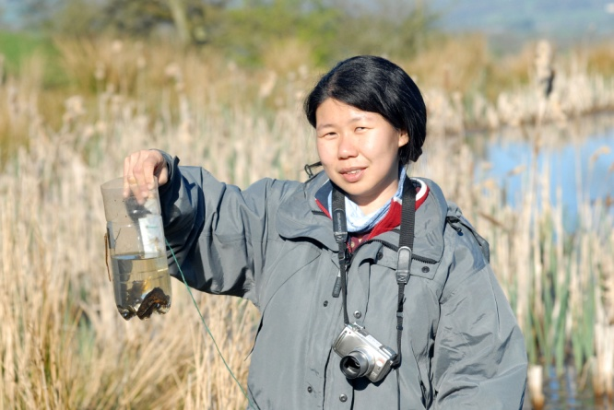
Although some of the combinations shown in Fig. 1, especially those marked in red or purple, may be desirable they are unlikely to be possible on grounds of either cost or required surveyor effort. On the other hand, combinations marked in green or to a lesser extent in yellow, may be possible given reasonable organisation, funding, and surveyor availability. For certain species, predictive modelling can now be used to overcome the problem of a prohibitive survey effort.
Survey protocols for amphibians
There are many recognised methods of detecting, and capturing, amphibians, but only five in widespread use in the UK – bottle trapping, netting, pitfall trapping, torching and visual searches. Searches of suitable terrestrial refugia may also be made (Froglife, 2003). In areas outside the UK call surveys are often used for frogs or toads, but as the majority of species in most areas of the UK are newts, which are silent, call surveys are not considered further here. Calls of natterjack toads may, however, be useful to determine their presence and may give some indication of numbers. Pitfall traps are effective, but are expensive to set up and require regular checking. For great crested newts, and some other species, additional licensing arrangements are required before the methodology can be used, in any case the cost implications have tended to mean that pitfall trapping is normally used in conjunction with mitigation projects, and, to a lesser extent, for scientific research.
Figure 2. Bottle trapping can be a highly effective method for great crested newts
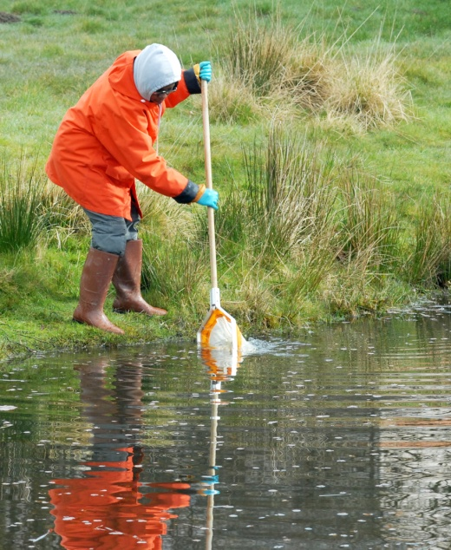
Of the remaining four methods, bottle trapping is highly effective for newts, whether at adult or larval stages, but is less effective for adult frogs (although tadpoles are sometimes caught in large numbers), and of little or no value for common toads. An advantage of bottle trapping is that difficult identification problems can be quickly resolved (for example distinguishing between female palmate and smooth newts). Disadvantages include the need for double visits, once to set and once to open the traps, and welfare issues for animals in periods of hot weather. Bottle traps should be laid along the shoreline at 2 m intervals (Griffiths et al., 1996; English Nature 2001).
Figure 3. Netting is useful but may be less effective than other methods
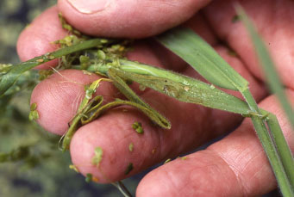
Unless carried out in conjunction with torching, netting is generally less effective than other methods for detecting newts, and there may be concerns over damage caused to the gills of larval newts in particular. We only recommend netting as a back-up to the other, more effective, methods listed here, or where the alternative methods are impractical.
Torching after dark can be highly effective for certain species, in particular adult great crested newts, and has the advantage that a survey can be completed in a single visit, rather than the two required to complete a single survey by bottle trapping. However, female palmate and smooth newts are difficult to separate by this method, as are larvae of the two species. Frog and toad tadpoles may also be surprisingly hard to separate by torchlight.
Figure 4. Daylight visual surveys are useful for some species. The folded grass stem here is characteristic for newt eggs.
Visual surveys are defined as daytime surveys using eyes only. They are less effective than night time torching for newts, but can be useful for adult frogs and toads at breeding times. They are also useful for spawn counts, and detecting frog and toad tadpoles under suitable conditions. A particular use has been to detect great crested newt eggs, for which the technique is highly effective, as long as the surveyor is aware of what to search for. A description of the advantages and disadvantages of each method is given in Gent and Gibson (1998). As no single survey method is ideal, we recommend a combination of methods for each type of survey as follows:
Presence/Absence surveys
In a recent study (Sewell et al. 2010) it was found that for presence/absence surveys for amphibians four surveys were usually sufficient, for most species (but not great crested newt – see below), to be 95% certain that if a species was not detected it was truly absent, as long as a combination of methods were used (bottle trapping, torching, netting and visual searches) and the surveys are carried out under appropriate conditions and timeframes. English Nature (2001) makes similar recommendations for great crested newt survey methods. There are, however, differences in the recommended timings. The English Nature mitigation guidelines recommend mid March-Mid June for surveys, with a preference for mid April to mid May. Sewell et al. (2010), in contrast, recommend one survey in March followed by three between mid April and the end of May. There is only a slight difference between these two studies. The Sewell et al. (2010) study was examining all common British amphibian species, whilst the English Nature guidelines were examining great crested newts only. The Sewell et al. (2010) March survey was primarily intended to pick up the timings when adult frogs and/or toads were likely to be in ponds. The choice of timings for presence/absence surveys for amphibians will therefore depend on how many species are of interest. Where the presence of great crested newts is suspected we therefore recommend an increase in the number of surveys for presence/absence to six. This higher number of surveys is especially important at sites where the detectability is low (Sewell et al., 2010). Four surveys per pond is sufficient within the core range of the species and at sites where detectability is likely to be high, for example in peak season at small-medium sized ponds with high water clarity. Six surveys would be needed on the edge of range (Zone B in Oldham et al. 2000), at upland sites, at the start or end of the season, or at sites where detectability is expected to be lower than normal, for example large, turbid or vegetation-covered ponds. Equally, the number of surveys may need to be increased at sites where populations are likely to be small. Use of bottle trapping is also important, especially at the edge of range. The Sewell et al. (2010) study examined a number of sites in Wales where the presence of great crested newts was only confirmed by bottle trapping, whilst torching, visual searches and netting all failed to detect the species. In core areas of the range, where population densities are often higher, torching may be the more effective method. However, we do emphasise the need of multiple detection methods both for this and other species.
Searches of terrestrial refugia may also be made (Froglife, 2003), but as newt species can be very adept at hiding, non-detection should not be taken as providing evidence of absence.
Sewell et al. (2010) demonstrated a relationship between mean overnight water temperature and detectability of great crested newts. As survey effort required is directly related to detectability, more surveys will be required at lower water temperatures (Fig. 5).
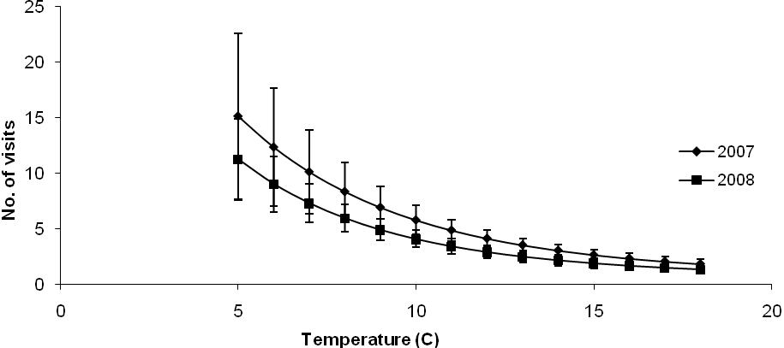
Fig. 5. The relationship between water temperature and survey effort required to detect great crested newts over two years from Sewell et al., 2010.

It is worth emphasising that Fig. 5 is for surveys carried out during the peak season of mid- April to late May. Unseasonally warm weather earlier in the year, or cool weather later in the year, will not yield the same changes in detectability. It can be seen from Fig. 5 that for water temperatures of 10º C or lower the number of survey visits needs to be progressively increased as water temperature declines. Therefore we recommend that water temperature be recorded on each survey (preferably when traps are laid), and the number of survey visits increased if the temperature is 10ºC or lower. We do appreciate that many surveyors work by air rather than water temperature, but models that incorporated water rather than air temperature as a covariate of detection accounted for >99% of model weight.
Population counts and densities
For great crested newts the recommendations by English Nature (2001) suggest six surveys in suitable weather conditions using both bottle trapping and torch surveys. Our own experience is that the optimum number of surveys for maximum counts is 7-8 (Sewell et al. 2005) The English Nature mitigation guidelines for great crested newts prefer maximum counts to densities as a means of population assessments on the basis that a small trapping sample will produce a very variable proportion of the newts actually present, and that population estimates derived from these samples are unlikely to be accurate. Populations are classed on the maximum count, with up to 10 being classed as small, 11-100 as medium, and 100+ as large. Alternatively, populations can be categorised as low, good or exceptional using a system originally created for the selection of biological SSSIs by the Nature Conservancy Council in 1989 (Gent and Gibson, 1998; Langton et al. 2001)
Population estimates
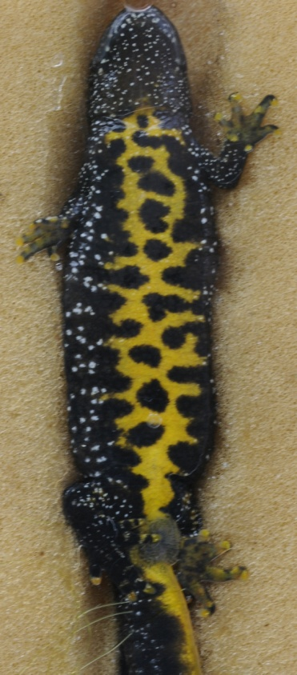
English Nature (2001) suggests two methods of estimating a population. Firstly, a pond may be drift fenced in conjunction with pitfall traps, with a survey effort of at least 100 days. Secondly they suggested capture-mark-recapture using bottle traps and netting, in which case at least 20 visits were suggested. In both scenarios timings were suggested as early February, and continuing through to late May.
In 2005 we tested this combination at a site with a known great crested newt population. Neither method provided a reliable estimate of the small known population. Some newts lived their entire lives in or close to the pond, and thus never had to pass through the drift fence, whilst others paid fleeting visits to the ponds concerned and were never caught in the bottle traps. Long term population estimation is probably best achieved by annualising capture data from bottle traps over a multi-year period and using statistical software, such as MARK, to estimate the annual capture rates. Population estimates for each year can then be obtained. Such estimates are likely to be restricted to a few long-term studies, an example for a great crested newt population is provided by Griffiths et al. (2010). The recommendation for the number of nights of operation for the drift fence for great crested newts is 60 nights, with the emphasis that this figure refers to nights with suitable weather conditions only. The recommendation also refers to presence/absence surveys and is therefore probably insufficient for either population estimation or catch depletion purposes.
Figure 6. The individual belly patterns of great crested newts make them an ideal subject for capture-mark-recapture studies
For common frogs it is possible to gain an estimate of the number of females in a population by measuring the area of the spawn mat and reading off the number of clumps from a chart (Griffiths et al. 1996). For common toads a head count during the breeding season may be the most effective means of estimating the population, but may underestimate the true population size. Counts should include the animals around the breeding site as well as animals actually in the water. Practically this may be difficult to achieve, as the breeding aggregation at a pond may be only a few days, and timing can be difficult to predict.
For studies based on short-term data, collected within a single survey season for closed populations, we recommend the Schnabel method, or program CAPTURE.
Population depletion
As removal is usually intended to relocate an entire population from a site it has much in common with the previous category, especially the need to use both bottle trapping and drift fencing in order to reach an entire population of newts. To maximise the catch it is important to have the drift fence in place before newts migrate into the pond at the start of the breeding season. This can be any time between mid February and early April, with males tending to move in earlier than females. There are relatively few data as yet on how long such systems should be left in operation to reliably remove an entire population. The few datasets that do exist show that after the initial migrations at the start of the breeding season there can be gaps of up to 10 days between captures for great crested newts. Checking should continue for at least this long after the last capture, although we do expect this recommendation to be extended as further information becomes available.
In addition to captures during the immigration period, described above, captures during the period when animals are leaving the pond are also possible. Removal may also incorporate captures during a pond drain-down and terrestrial captures away from a pond. Again, further guidance will be incorporated as it becomes available.

Survey protocols for reptiles
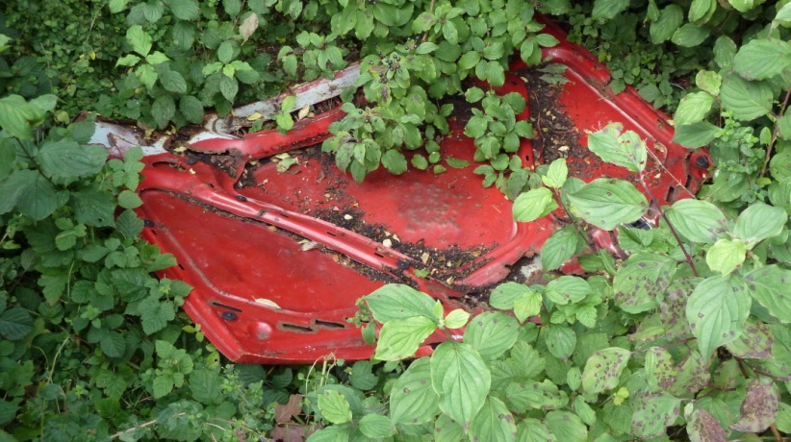
Compared to amphibians, there are relatively few methods of detecting and capturing reptiles. Fundamentally, only two methods are used commonly in the UK, directed visual transects and refugia searching. In the case of the latter, refugia may be natural, man-made (usually discarded rubbish), or laid deliberately for the survey. In the case of the latter tins or roofing felts (at least 0.5m x 0.5m) are the most popular materials, but other types can also be used effectively and the most effective size is also debateable.. These are often referred to as artificial cover objects (ACOs). Considerations over which material(s) to use are governed by cost, target species, and portability as well as the personal preference of the surveyor. As felt and tin react differently to solar radiation, with tin warming quickly, but also cooling faster than felts, we recommend a combination of materials in most situations. Siting of ACOs is important; to increase the likelihood of detections, ideally they should be laid in a south-facing position, and preferably partially concealed in vegetation. ACOs that do not receive direct solar radiation, at least for part of the day, are unlikely to be used.
Figure 7. Discarded rubbish can make good refugia for reptiles. Up to eight slow-worms at once were found underneath this old car bonnet.
It should be noted that directed transect walks are required in addition to ACO searches. Sand lizards use ACOs comparatively rarely, whilst adders may use them at some sites, but not others. Thus, failure to carry out transect walks may result in the under-recording of these species.
It should be noted that the following recommendations are aimed at surveyors of medium to high experience. Inexperienced surveyors will require training, especially on visual transects, and the number of surveys may need be increased to allow for experience.
Presence/Absence surveys
For presence/absence purposes, a recent study (Sewell et al. 2012) has shown that four-five survey visits (depending on species) are usually sufficient to detect 95% of occupied sites, at least for the commoner British reptile species, providing a combination of both tins and other artificial ACOs are used in addition to transects. However, the Sewell et al. (2012) study has a number of important caveats, which must be taken into consideration when arriving at a suitable number of surveys for mitigation purposes. Firstly, the study was undertaken on behalf of NARRS (the National Amphibian and Reptile Recording Scheme). Within a limited geographic area, surveyors on this scheme are able to pick the sites most likely to contain reptiles, which means that detection rates are higher than in the more marginal habitats that are usually surveyed as part of mitigation studies. Also NARRS sites are more likely to have had ACOs laid for a while before surveys begin. Therefore, we recommend increasing the number of surveys to seven unless it can be proved that refugia have been in place for a sufficiently long period, and that the area is one where reptile detectability is high.
If the area is one likely to support sand lizards, however, the Sewell et al. (2012) study suggests that up to seven surveys will be needed for NARRS purposes, and as many as 11 for mitigation on marginal reptile sites. The same study suggested that at least 30 refugia should be laid for presence/absence purposes, but this number applied regardless of the size of site as long as the ACOs were appropriately positioned. We have not reviewed the number of ACOs required for other purposes, and therefore make no recommendations. Instead we recommend examination of existing literature, e.g. Reading (1997).
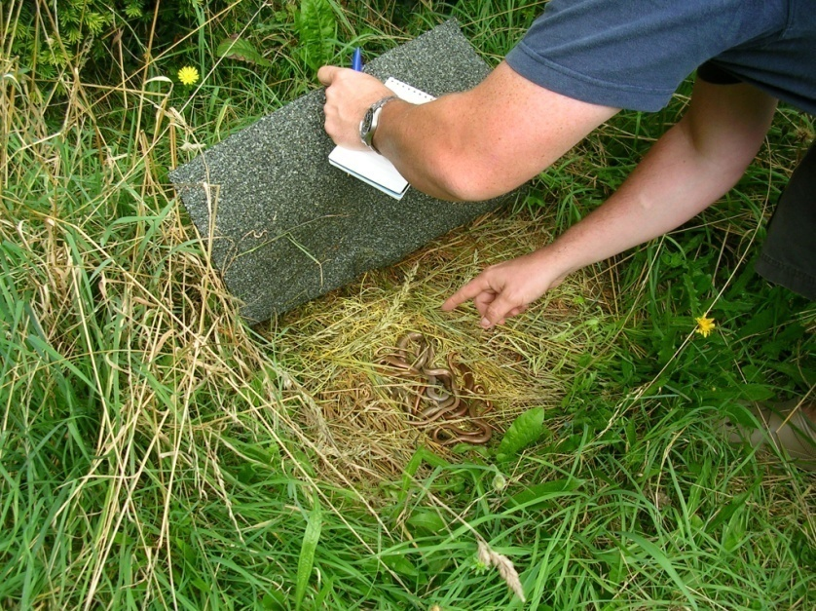
Because of their different thermal properties, explained above, we recommend a combination of cover object materials for presence/absence surveys.
Previous studies in continental Europe (Kéry, 2002; Kéry and Schmidt, 2008) – but examining most of the species found in the UK - found lower detection rates than those reported in the Sewell et al. (2012) study, but only used transects as a single method of detection. Therefore, if ACOs are not included in the surveys, the number of survey visits needs to be increased. Equally, if transects were excluded from a programme and the surveyor merely moved from refuge to refuge without checking the survey route for basking animals, the number of survey visits would also need to be increased in compensation.
Figure 8. Checking for slow-worms under felt refugia
Surveys should ideally be spread across the survey season. Detectability can be lower in March, and some species, such as smooth snakes may not have emerged from hibernation. For this reason we prefer presence/absence surveys for reptiles to be timed to start from April onwards. However, we do recognise that warm days in March can be useful for reptile surveys, especially for finding animals emerging from hibernation sites.
Population counts and densities
Many of the comments given above for amphibian counts and densities apply equally to reptiles. Indeed, as the site edge from the animal’s viewpoint may not be clearly known, and as many species can be highly cryptic, it is even more difficult to draw reliable conclusions from the data that counts and densities provide. Within these caveats, population class assessments may be carried out using the guidance given in the Reptile Mitigation Guidelines (Natural England, 2011). The system calls for peak counts, with size classes varying from species to species, combined with a habitat suitability assessment.
Population estimates
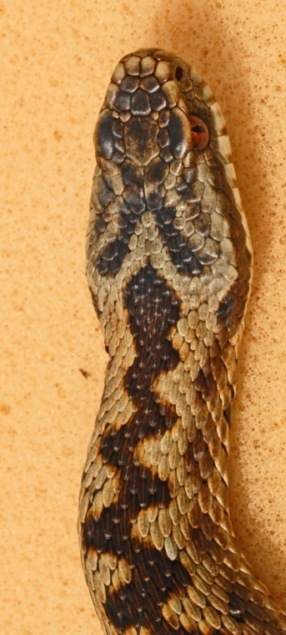
Natural England (2011) recommends capture-mark-recapture techniques for population estimation. We concur with this, but note that whilst individual recognition is relatively easy for adders (using head patterns) and grass snakes (using belly patterns), individual recognition is not yet well established for most lizard species (but see Dent 1986, Smith 1990 and Riddell, 1996) although, with care, it does seem to be workable in small populations of slow-worms. As with amphibian studies above, long term population estimation is probably best achieved by annualising capture data over a multi-year period and using statistical software, such as MARK, to estimate the annual capture rates. Population estimates for each year can then be obtained. For studies based on closed populations collected within a single survey season, we again recommend the Schnabel method, or program CAPTURE.
Figure 9. Head patterns of adders are unique to individuals and are useful for population estimates.
We also concur with Natural England that population estimates based on habitat extent and a theoretical population density are often highly unreliable, and we do not recommend their use unless it can be demonstrated that the estimate is reasonable.
Catch depletion
The remarks above relating to amphibians apply similarly to reptiles. In some respects reptiles are even more difficult. With amphibians the boundary of the site, at least in the breeding season, is clear. For reptiles the site boundary may be highly indistinct, at least to human eyes, and the animals less easy to capture than most amphibians are. There are few published studies on the removal of reptiles from a site. Platenberg and Griffiths (1999) is an exception, but a key message from consultants involved in the workshops that formed a part of this programme is that current guidance on this subject is inadequate. A number of reptile data sets from previous mitigation projects have been made available, and guidance will be added as analysis is completed.
Literature
Dent, S. (1996) The ecology of the sand lizard (Lacerta agilis) in forestry plantations and comparisons with the common lizard (Lacerta vivipara). PhD thesis, University of Southampton.
English Nature (2001). Great crested newt mitigation guidelines. English Nature, Peterborough.
Froglife (1999). Reptile survey, An introduction to planning, conducting and interpreting surveys for snake and lizard conservation. Froglife advice sheet 10, http://www.froglife.org/advice/sheets/htm
Froglife (2003). Surveying for (great crested) newt conservation. Froglife advice sheet 11, http://www.froglife.org/advice/sheets.htm
Gent, A. and Gibson, S. (1998). Herpetofauna Workers’ Manual. Peterborough, UK. Joint Nature Conservation Committee.( http://jncc.defra.gov.uk/page-3325
Gleed-Owen, C., Buckley, J., Coneybeer, J., Gent, T., McCracken, M., Moulton. N. Wright, D. (2005). Costed plans and options for herpetofauna surveillance and monitoring. English Nature Research Report no. 663, English Nature, Peterborough.
Griffiths, R.A., Raper, S.J., Brady, L.D. (1996). Evaluation of a standard method for surveying common frogs Rana temporaria and newts Triturus cristatus, T. helveticus and T. vulgaris. JNCC Report no. 259. Joint Nature Conservation Committee, Peterborough.
Griffiths, R., Sewell, D., McCrea, R.S., (2010). Dynamics of a declining amphibian metapopulation: survival, dispersal and the impact of climate. Biological Conservation 143, 485-491.
JNCC (2004). Common standards monitoring guidance for reptiles and amphibians. Joint Nature Conservation Committee, Peterborough (http://jncc.defra.gov.uk/page-2223#download)
Kéry, M. (2002). Inferring the absence of a species – a case study of snakes. Journal of Wildlife Management 66: 330-338.
Kéry, M. and Schmidt, B.R., (2008). Imperfect detection and its consequences for monitoring for conservation. Community Ecology 9: 207-216.
Langton, T., Beckett, C. and Foster, J. (2001). Great crested newt conservation handbook. Froglife, Halesworth.
Natural England (2011) Reptile mitigation guidelines (1st draft) Natural England Technical Information Note TIN102, Natural England, Peterborough.
Platenberg, R.J. and Griffiths, R.A., (1999). Translocation of slow-worms (Anguis fragilis) as a mitigation strategy: a case study from south-east England. Biological Conservation 90: 125-132.
Reading C.J. (1997) A proposed standard method for surveying reptiles on dry lowland heath. Journal of Applied Ecology 34: 1057-1069.

Riddell, A. (1996). Monitoring slow-worms and common lizards, with special reference to refugia materials, refugia occupancy and individual recognition in Reptile survey methods: proceedings of a seminar held on 27 November 1995 at the Zoological Society of London’s meeting rooms, Regent’s Park, London, ed. by J. Foster and & T. Gent, 46-60. Peterborough, English Nature. (English Nature Science. No. 27).
Sewell, D., Griffiths, R.A., Galama, R. and Gamboni, I. (2005). Evaluation of methods to assess the population status of great crested newts (Triturus cristatus). Unpublished English Nature Research Report, Peterborough.
Sewell, D., Beebee, T.J.C. and Griffiths, R.A. (2010). Optimising biodiversity assessments by volunteers: the application of occupancy modelling to large-scale amphibian surveys. Biological Conservation 143, 2102-2110.
Sewell, D., Guillera-Arroita, G., Griffiths, R.A. and Beebee, T.J.C. (2012). When is a species declining? Optimizing survey effort to detect population changes in reptiles. PLoS ONE 7(8): e43387. doi:10.1371/journal.pone.0043387
Smith, N.D. (1990). The ecology of the slow-worm (Anguis fragilis) in southern England. MPhil thesis, University of Southampton.
Thomsen, P.F., Kielgast, J., Iversen, L.L., Wiuf, C., Rasmussen, M., Gilbert, M.T.P., Orlando, L. and Willerslev, E. (2011). Monitoring endangered freshwater biodiversity using environmental DNA. 21: 2565-2573.

