West Yorkshire Toad Summit programme

1.00 Arrivals, tea & coffee
1.30 Opening by Sheila Gundry, Froglife (Chair)
And the Mayor of Calderdale, Councillor Dot Foster
1.40 Why a Toad Summit? Gordon Maclellan, ‘Creeping Toad’ and Froglife Trustee
1.50 Toad Patrols in the UK - Angela Julian, Co-ordinator, Amphibian and Reptile Groups UK
2.10 The wonders of our local toads, past and present - Steve Blacksmith, Chair of Halifax Scientific Society
2.30 Cottonstones Toad Patrol – Charlotte Weightman
2.40 Leeming Reservoir Toad Patrol – Jane Topham
2.50 Mirfield area Toad Patrols - Clare & Andy McIlwraith, Chairs, Yorkshire Amphibian and Reptile group
3.00 Meet the Toad Patrols networking session and ask our experts at the ‘Toad Top Table’
3.50 Toad story - Christine McMahon, Storyteller
4.10 How the Local Authority can help - Hugh Firman, Conservation Officer, Calderdale Council
4.30 Close

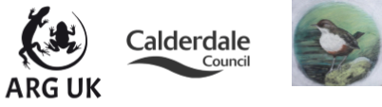
Halifax Scientific Society

